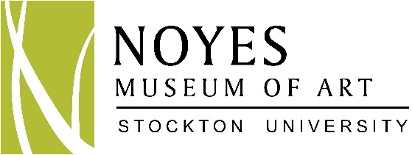

High School Internship Opportunities

Internships
The Noyes Museum of Art of Stockton University presents exciting exhibitions, cultural events, and innovative programs in the arts.

High school interns are offered a chance to make real contributions while gaining experience in the museum field. The Noyes Museum of Art is seeking interns who are mature, energetic, enthusiastic, and self-motivated. These are unpaid positions.

Internship Objectives
The Museum provides interns with an educational experience where students gain first hand practical knowledge of the museum field. This program provides the opportunity to learn about aspects of museum operations and to work on projects under the guidance of the Education Director.

Selection Process
Interested candidates must be a junior or senior, have a strong interest in art or art history, have a minimum of a 3.0 grade average, provide two recommendation letters, fill out the application form and email or mail it to Saskia Schmidt, Director of Education (see address information at end of form). After receipt of the application, candidates of interest will be contacted to schedule an appointment for an interview. Accepted interns must commit to at least 4 Saturdays over the course of the school year or 4 week days during the summer. Interns are encouraged to attend monthly Museum events and activities.

Potential Projects

Interns will become acquainted with the general functions and operations of the Museum. Interns will be supervised by the Education Director.

Education
Assist Director of Education with children’s art classes
Summer interns: Assist with summer art camps for children
Train to become a museum guide, leading school tours for young children
Additional programs: children’s activities, special event projects, and assistance with the “Young at Art” Gallery

High School Internship Application: 2018 -2019

Specify Internship Program for which you are applying:

____ Spring 2018  Deadline 1/10/18  ____ Spring 2019  Deadline 1/10/19 |  |  | ____ Summer 2018  Deadline 6/1/18  ____ Summer 2019  Deadline 6/1/19 | ____ Fall 2018  Deadline 8/1/18  ____ Fall 2019  Deadline 8/1/19

Last Name First Name

High School Projected Graduation Date

Home Address

E-mail Address Phone Number

Parent’s/Guardian’s Last Name First Name

Parent’s/Guardian’s Phone Number Cell Phone Number

Parent’s/Guardian’s Email Address

I give my child _____________________________ permission to participate in The Noyes Museum of Art’s High School Internship Program.

Parent’s/Guardian’s Signature Date

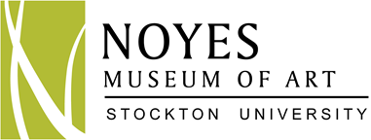

Please complete the following essay topic. It should be between 300-500 words.
(Attach a separate sheet to application)

Why are you interested in participating in an internship at the Noyes Museum of Art?

Your Availability - Interns must work with a set schedule, agreed upon in advance, for a minimum of 4 Saturdays over the course of the school year or 4 weekdays during the summer months:
Hours of Operation - Kramer Hall (Hammonton): Mon. – Fri. 9:30am–4:30pm; Arts Garage: (Atlantic City) Wed.-Sun.:11am-6pm

__________Sunday | __________Monday | __________Tuesday | __________Wednesday
__________Thursday | __________Friday | __________Saturday

References - not related to applicant (One reference must be a teacher):

Name Phone Number E-mail Address Relationship

Name Phone Number E-mail Address Relationship

Name of your art teacher:

Name Phone Number Name of School

Email Address

How did you learn about this program (check all that apply)?

__________Noyes Website | ___________Visit to the Noyes
__________Former Noyes Intern | ___________Other (please specify)________________________

Email or mail your application, essay, and a letter of recommendation to:
Attn.: Saskia Schmidt, Director of Education
The Noyes Museum of Art of Stockton University
Kramer Hall
30 Front Street
Hammonton, NJ 08037
609.652.1776 x5200
Saskia.Schmidt@Stockton.edu

