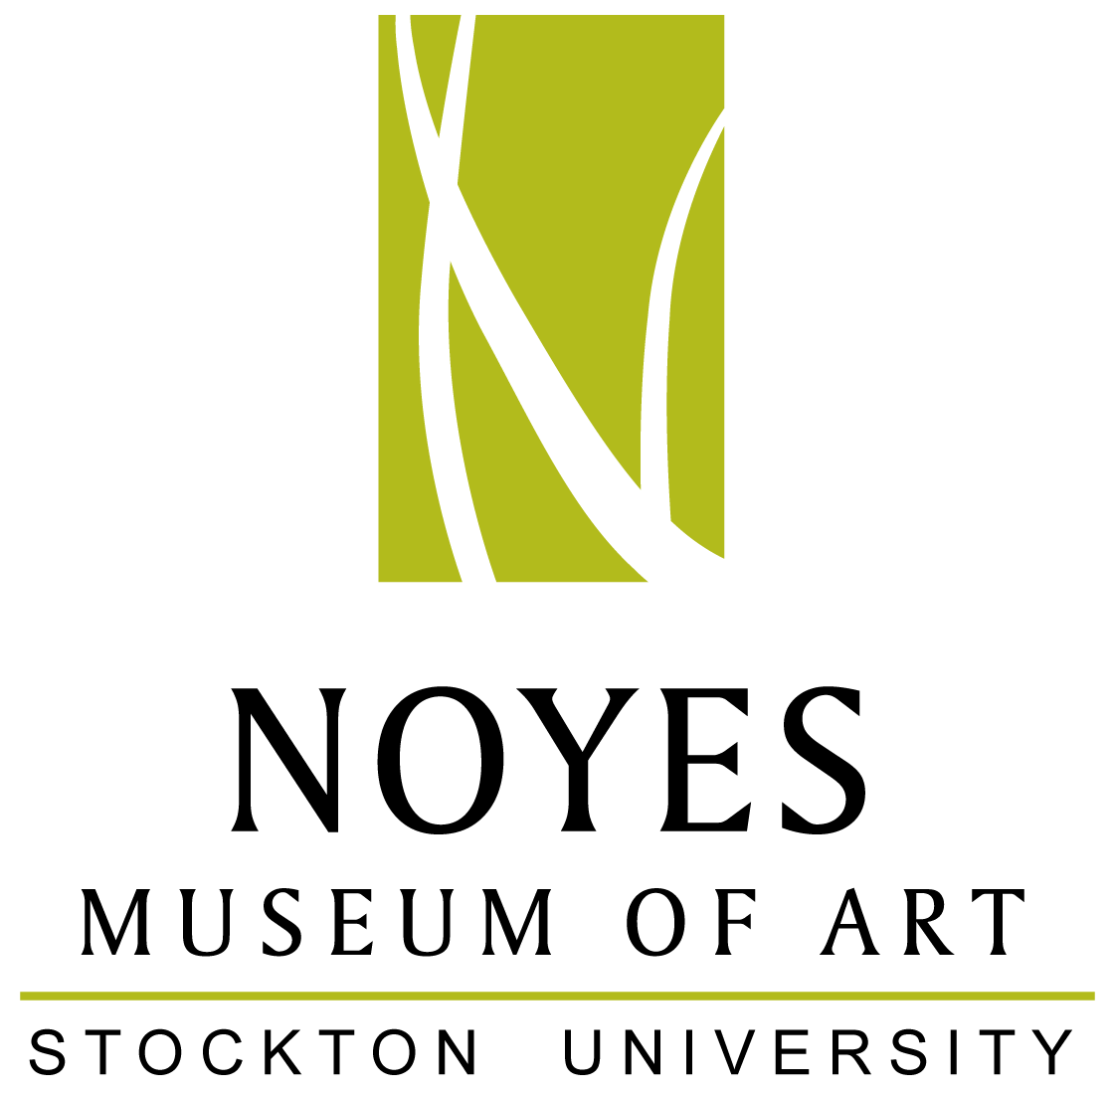

The Noyes Museum of Art of Stockton University
Noyes Gallery: Kramer Hall, 30 Front St., Hammonton, NJ 08037 • (609) 626-3420 • www.noyesmuseum.org
Noyes Shop: 5 Second Street, Hammonton, NJ 08037 • (609) 561-8006
Arts Garage: 2200 Fairmount Ave., Atlantic City, NJ 08401 • (609) 626-3805 • artsgarageac.com

Press Release For Immediate Release
Media Contact: Saskia Schmidt, Director of Education October 19, 2016
education@noyesmuseum.org
(609) 626-3420

Noyes Museum: Fall Events

HAMMONTON, NJ –

NOYES GALLERY AT KRAMER HALL, HAMMONTON

HAMMONTON, NJ: During Hammonton’s Third Thursday event on October 20th, The Noyes Gallery at Stockton’s Kramer Hall at 30 Front Street will stay open late from 6:00 - 8:00pm. Be sure to visit the Hammonton: 150 Years of Agriculture exhibition, on view through December 31, 2016. Utilizing artifacts and artists’ interpretations, this exhibition highlights 150 years of agriculture in Hammonton. The Noyes Gallery is free and open to the public.

The Noyes Shop in Hammonton at 5 South Second Street is also open late on October 20th from 6:00 – 8:00pm, and will celebrate Third Thursday with a free craft. Noyes Shop staff will provide instructions on how to make your own Halloween or autumn-themed felt patches and pins.

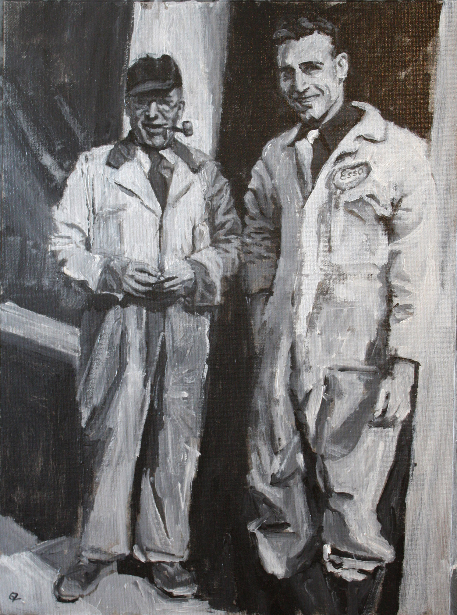
For Hammonton’s Third Thursday on November 17th, The Noyes Gallery at Kramer Hall will host a free reception celebrating the opening of the Noyes Associate Artist Members Exhibition. This exhibition is on view from November 9, 2016 through January 15, 2017. Meet the artists and enjoy refreshments, wine, and cheese from 6:00 - 8:00pm.

The Associate Artist exhibition showcases the work of thirteen artists creating outstanding artwork throughout the state. Works in mixed media, painting, and sculpture will be featured. This annual exhibition continues the tradition of celebrating recent work from New Jersey artists, all selected by jury to be a part of the prestigious Artist Member’s group.

Associate Artists included in this exhibition are: Jacqueline Boyd, Charles Branigan, Vicky Culver, t.a. hahn, James Kent, Dennis Loughlin, Bill Parker, Glynnis Reed, Christina Sanes, Judith Saylor, Mary Trivelli Schatz, Grace Zambelli, and Michael Zambelli.
Grace Zambelli, The Esso Men, Oil on canvas

For more information call (609) 626-3420 or visit www.noyesmuseum.org.

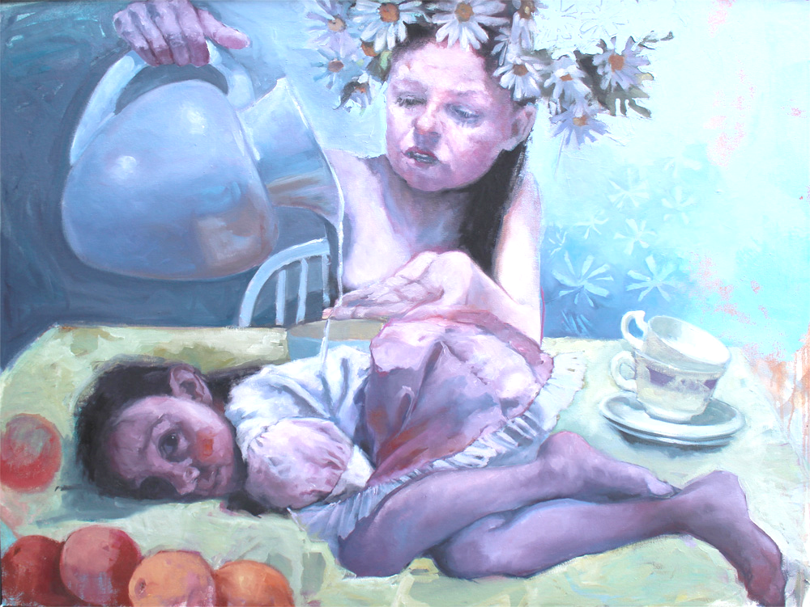
ARTS GARAGE, ATLANTIC CITY:

ATLANTIC CITY, NJ: The Noyes Arts Garage of Stockton University is proud to host its free monthly Second Friday event on Friday, November 11 from 6:00 – 8:00pm. This reception celebrates the opening of three exhibitions: Noyes Signature Artist Members, Yujin Song, and the Stockton Students Art Club, and includes a book signing by Daniel Doster-Mann, author of Abused Intimacy. Enjoy live music, light refreshments, and a wine tasting by the Iron Room. Second Friday at the Arts Garage is a family-friendly free event. A craft project for all ages will be offered in the art workshop.
Jude Harzer, Cleansing, Oil on canvas
The annual Noyes Signature Artists Exhibition opens at the Arts Garage on Friday, November 4 and runs through January 8, 2017. Showcasing recent work by twenty-one outstanding artists from throughout New Jersey, it includes mixed-media, assemblage, painting, ceramics, furniture, and sculpture. Highlights include Jude Harzer’s Cleansing, a provocative painting featuring children as observers and guardians of inter-generational mythologies. Amy Evans’ In the Blue series of dream-like cyanotypes reflect upon the mythical quality of memories. Sheila Grabarsky’s Fantasy Garden is an abstract painting filled with light and color and is featured in a newly released film, American Pastoral. Bette Blank’s lively illustrative painting adds a bit of humorous storytelling to the exhibition.

Artists in the Noyes Signature exhibition: Geoffrey Agrons, Bette Blank, Amy Evans, Joanie Gagnon San Chirico, Sheila Grabarsky, Glen Guarino, Jude Harzer, Eileen Kennedy, Joyce Lawrence, Alice McEnerney-Cook, Lucretia McGuff-Silverman, Tony Migliaccio, Kristin Myers, Vincent Nardone, Laura Petrovich-Cheney, Isabella Pizzano, Lou Riccio, Miklos Sebek, Karen Starrett, Lou Storey, and Skeffington Thomas.

Daniel Doster-Mann, a charismatic author and motivational speaker, will be on hand to sign his book, Abused Intimacy, during the November 11 Second Friday event at the Arts Garage. Growing up in a family battling with addiction, he was bullied and abused as a child. Doster-Mann has a passion for encouraging and inspiring people from all walks of life to be heard, understood and healed.

Yujin Song is a painter from Jeju, South Korea. Currently an exchange student at Stockton University, she is visiting from Jeju National University. Her artwork, on view at the Arts Garage from November 5 – 29, is a form of documentation, capturing the moment of a personal connection or a strong emotion. “I switched from painting people to depicting places, after realizing that portraits limit my ability to tell a story,” Song states.

The Stockton Art Club Exhibition, in the Osprey Gallery at the Arts Garage, is on view from November 5 – 29, includes the work of talented Stockton University students. This exciting annual exhibition is curated and installed by the students themselves.

For more information call (609) 626-3805 or visit artsgarageac.com.

Current Exhibitions at the Noyes Arts Garage of Stockton University - Atlantic City:

- The African American Heritage Museum of Southern New Jersey:
JET, BLACK, BROWN and TAN: The Legacy of John H. Johnson October 1 – December 30, 2016

- The Noyes/Stockton Annex: Hak Vogrin: A Retrospective August 5 – October 30, 2016

- The Noyes/Stockton Gallery: Grand Vista: 21st Century Landscapes August 5 – October 30, 2016

- The Atlantic City Gallery:
FOCUS ON ECONOMIC INEQUALITY: A Community Exhibition October 8 - 30, 2016

- The Osprey Gallery:
FOCUS ON ECONOMIC INEQUALITY: A Community Exhibition October 8 - 30, 2016

Upcoming Events at the Noyes Arts Garage of Stockton University - Atlantic City:

Watercolor Class with Stephanie Segal Miller, 2 – 4:30pm October 30, 2016
Second Friday (The public is welcome: 2nd Friday of Every Month) November 11, 2016
Free Social Media Workshop: 6:00 – 8:30pm November 17, 2016
AC Craft Market: Small Business Saturday! November 26, 2016

Current Exhibitions of the Noyes Museum of Art of Stockton University:

- Noyes Gallery at Stockton’s Kramer Hall, Hammonton:
Hammonton: 150 Years of Agriculture August 22 – December 31, 2016

- AtlanticCare Regional Medical Center - Healing Arts Program, Atlantic City Campus
Lou Storey: The Best Medicine September 9, 2016 – January 1, 2017

- Noyes Gallery at Seaview in Galloway, New Jersey:
Pulp: Works from the Noyes Permanent Collection September 1, 2016 – January 8, 2017

Cathleen Engelsen: Paintings & Prints September 1, 2016 – January 8, 2017

####

About:
The Noyes Museum of Art was founded in Oceanville, NJ, in 1983 to collect, preserve, and exhibit American fine and folk art, with an emphasis on New Jersey artists and folk art forms. Today, the Noyes Museum’s exhibitions reflect the area’s cultural heritage, while also presenting significant artwork by regional and national artists working in a variety of media. The Noyes has expanded to include galleries in Hammonton, Atlantic City, and at Seaview Resort in Galloway. The Noyes Shop: Hammonton opened in 2008 and specializes in custom framing. The Noyes Gallery at Kramer Hall in Hammonton is the newest addition to the vibrant Arts District in Downtown Hammonton, and The Noyes Museum’s satellite exhibition spaces. It is located at 30 Front Street, Hammonton, NJ 08037. In February 2010, The Noyes Museum of Art formed a partnership with Stockton College (now Stockton University) to form The Noyes Museum of Art of Stockton University. Through a 2013 partnership with the CRDA, The Noyes Museum opened The Noyes Arts Garage of Stockton University, a unique multi-use arts and retail space at 2200 Fairmount Avenue in Atlantic City.

The Museum is a 501 (c)(3) organization, with general funding provided by: the New Jersey State Council on the Art/Department of State, a state partner of the National Endowment for the Arts; the Mr. and Mrs. Fred Winslow Noyes Foundation; Stockton University; and the Geraldine R. Dodge Foundation.

For information about The Noyes Museum of Art of Stockton University visit www.noyesmuseum.org or
call (609) 626-3420. Check us out on Facebook.

